Google Documents
Quick Start Guide
There are different ways of getting started using Google documents: you can create a new online document, you can upload an existing one, or you can use a template from the templates gallery.

Creating and saving a document
To create a new document, go to your Docs list, click the Create new drop-down menu, and select Document.
As you're working on your document, click the Save button in the top right corner of the document, enter a name for the document in the window that appears, and click OK. Then, you'll see your document in your Docs list.
To save a local copy of a document, you can download it to your to your U:\ drive folder. To do this, open your document, click the File menu and point your mouse to the Download as option. You'll see these file types: HTML (zipped), RTF, Word, Open Office, PDF, and plain text. Select a file type and click OK in the browser window that appears.

Uploading a document
You can upload existing documents to Google documents at any time. Here's how:
- Click the Upload button at the top of the sidebar in your Docs list page.
- Click Browse and select the document.
- Click Open.
- Click Upload File. The uploaded file appears in your Docs list.
- File types you can upload: .html .txt, .odt, .rtf, and Microsoft Word
- Size limits: Each document can be up to 1MB, plus up to 2MB per embedded image.

Using the templates gallery
If you want to quickly create a document, you can pick one of the templates in the templates gallery. Each template has standard text that you can replace with your own, and preset formatting that you can reuse.
Editing
Use the menus in the toolbar to change the font or the text size in your document. Simply select the text you'd like to change and click either the font menu, which lists Arial as the default font, or the text-size drop-down menu, set to 11pt by default. Choose a new font or text size, and the changes are applied to the selected text.
- Arial and Times New Roman appear as options in the font menu.
If you'd like to change the spacing of the document, click the line spacing button on the far-right of the toolbar.
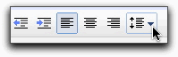
Then, select an option from the menu.
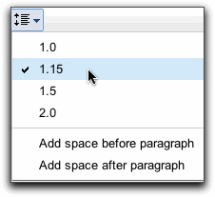

Inserting links
If you want to insert a link to a website or an online document as a reference, follow these steps:
- Click anywhere in your document where you'd like the link to appear.
- Click the Insert drop-down menu and select Link..., or click the link icon in the toolbar. The 'Edit Link' window appears.
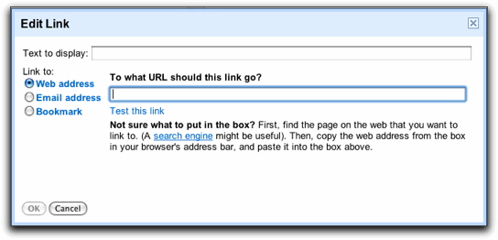
- Type the text you'd like to be displayed as the link (if you selected specific text, it will already appear in the 'Text to display' field). Leave this field blank if you want the full link to be displayed in your document.
- Select either 'Web address' or 'Email address.'
- Enter a URL (or an email address if you selected 'Email address') in the second text box.
- Click OK.

Adding comments
Comments are a handy way of adding notes to your regular document text and are visible to viewers and collaborators. These can be invaluable for communicating with collaborators about specific parts of the document, as well as making notes about changes you've made or would like to make. When you publish your document as a webpage or print it, the comments will disappear.
To add a comment to your document, follow these instructions:
- Place your cursor where you'd like your comment to appear.
- Click the Insert drop-down menu.
- Select the Comment icon.
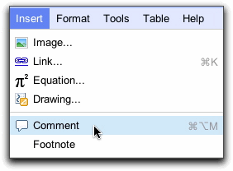
You can also use the keyboard shortcut Ctrl+Alt+M (Cmd+Option+ M for Mac) to insert a comment.
- Type your comment in the box that appears to the right of the document. Your username appears by default in the comment.
To delete a comment, simply click the trash icon in the comment box.
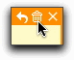

Inserting images
You can enhance your document by inserting an image. Here's how:
- Click the Insert drop-down menu from the toolbar and select Image.
- Depending on what image you'd like to add to the document, click Upload, URL, or Google Image Search, and follow these instructions:
  - Upload: Choose an image from your computer and click the Upload button.
  - URL: Type the URL of an image from the Web and click Select.
  - Google Image Search: Enter a search term to find an image using Google Image Search, and click Search images. Once you've found what you were looking for, click the image and the Select button.

Revision history
While you and your collaborators are editing a document, you can keep track of changes (and of the person who made them), and even revert to an older version by using 'Revision history.'
- From your document, click File > See revision history.
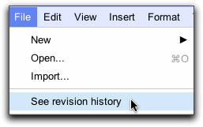
- Click a time stamp in the right column to see what changes were made at a given time or use the arrow keys to quickly scan through many revisions. Changes are color-coded based on each collaborator, making it easy to tell what has been added or deleted.
- If you would like to revert to the version you're currently viewing, click Restore this revision.
Note: Restoring your document to a previous version does not eliminate any versions of your document. Rather this version is "hopscotched" to the top of your revision history, maintaining all previous versions of your document, including the current version.
- If you would like to return to the current version of your document to continue editing, click the X in the upper right of the 'Document History' pane.

Sharing your document
Now that you've created your Google document, you can share it with your teacher and classmates. You can do this from your Docs list or directly from the document.
- From the Docs list, select the checkbox next to the document you want to share (you can also select multiple documents), and click the Share drop-down menu in the toolbar. Then, select 'Sharing settings.'
- From your document, click the Share drop-down menu in the top right corner of the page.
Then follow these instructions:
- At the bottom of the 'Sharing settings' window, under 'Add people,' type the email addresses of people you want to share your document with. You can add a single person or a mailing list. You can also choose from a list of your contacts.
- To the right of the list of names, select 'Can view' or 'Can edit' from the drop-down menu.
- If you'd like to add a message to your invitation, enter some text and click Share. To skip sending an invitation, deselect the option 'Send email notifications (recommended).' Your collaborators and viewers will still be able to access the document from their Docs lists, but won't receive an email invitation.
In the 'Sharing settings' dialog, you can also see who has access to your document, change how
much access people have, remove editors and viewers, and change your document's visibility option.
- You can explicitly share your document with up to 200 combined viewers and collaborators; however, if you publish your document, anyone will be able to access it.
- Up to 10 people may simultaneously edit and/or view a document.

Publishing
Once you're done creating and editing your document, you can publish it to a webpage. Just click the Share drop-down menu on the top right and choose Publish as webpage. Then, click Publish now.
You can send your document's web address to your teachers and classmates and they can enter it in their browser address bar to view your document.

Printing
If you want a hard copy of your document, you can print it from a PDF. Here's how you can print directly from a PDF:
- From within the document you'd like to print, select File > Print.

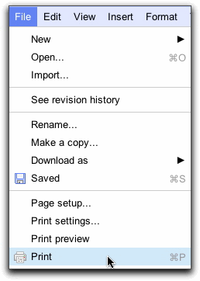
- A PDF appears with the print dialog box ready for printing.
If you'd like to add page numbers to your document before printing it, select Print settings... from the File menu and choose where you'd like the page number to appear. Once you've changed the settings, click Print at the bottom of the window. A PDF with a print dialog box appears.

